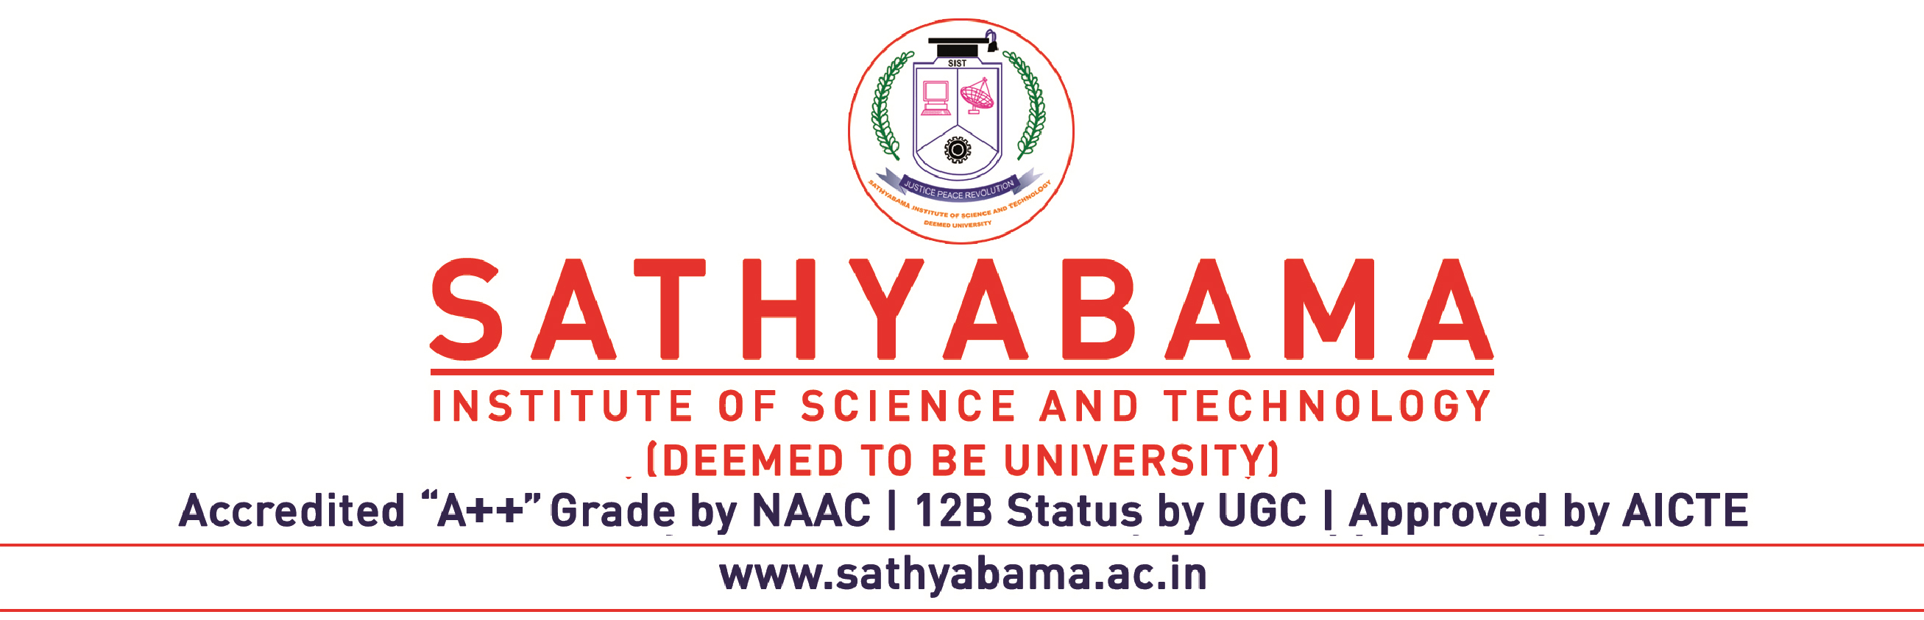

CENTRE FOR RESEARCH

Proceedings of the Ph.D Viva Voce Examination of Mr./Ms.________________________________________________
(Reg. No.___________________) held at _______________ am/pm on (date) _________________ in Sathyabama Institute of Science & Technology, Chennai.

The Ph.D Viva Voce Examination of Mr./Ms.________________________________________________
on his/her Ph.D Thesis entitled “_________________________________________________________________
___________________________________________________________________________________________
___________________________________________________________________________________________
___________________________________________________________________________________________”
was conducted in Sathyabama Institute of Science & Technology, Chennai – 119 at ______________ am/pm on(date)________________

The Following members of the Oral Examination Board were present:
1.______________________________________________________________National Examiner
2.______________________________________________________________Nominee of International Examiner
3.______________________________________________________________Supervisor & Convener

The Research Scholar Mr./Ms.___________________________________________________________________
presented the salient features of his/her Ph.D work. This was followed by questions from the audience including Research Scholars. The questions raised by the National Examiner and nominee of the International Examiner were also put to the research scholar. The research scholar answered / did not answer the questions to the full satisfaction of the board members and audience.

Based on the research scholar’s work, his/her presentation and also the clarification and answers by the research scholar to the questions, the board recommends/does not recommend that Mr./Ms.________________________________________________________ be awarded the Ph.D degree in the faculty of ______________________________________________________________________________.

Name & signature of the National Examiner

Name & signature of the Nominee of International Examiner

Name & signature of the Supervisor

Instructions to the candidates before conducting defending Viva Voce

Details to be submitted on the day of Viva Voce:
1. Covering letter from the Supervisor for having carried out all the corrections suggested by Indian / Foreign Examiner in the Thesis.
2. Viva Voce Examination fee as for Rs.20,000/- (Rupees Twenty Thousand Only)
Details to be submitted after defending Viva Voce
1. Two copies of A5, typed on both sides (All copies to be hard bound)
(Side sticker should be pasted in all the thesis)
2. In all the copies of A5 thesis the following should be enclosed immediately after the cover page.
a. Official letter duly signed by supervisor for having carried out the corrections suggested by
Indian/Foreign Examiner/Foreign Examiner Nominee
b. Ph.D Viva Voce notification
c. Copy of the Proceedings of the Ph.D Viva Voce Examination
3. In all the copies of A5 Thesis, the following should be enclosed at the back of thesis following the
Curriculum Vitae.
Indian & Foreign Examiner reports along with the answers to the questions posed should be enclosed.
Plagiarism Report.

